Reports Deployment with CMD

Open the “DSReports.rds” in the notepad change connection string.

For Web.config in Indigo.

<add key="urlReportServer" value="http://servername/ReportServer" />

<add key="ReportDomain" value="domain" />

<add key="ReportUserName" value="username" />

<add key="ReportPassword" value="decryptedpassword” />

<add key="ReportServerFolderName" value="Veneka.Indigo.ReportManagement" />

Run cmd as administrator

Go to the location where you copied the reports .

Eg: “C:\Users\veneka-13\Desktop\ReportsDeployment”

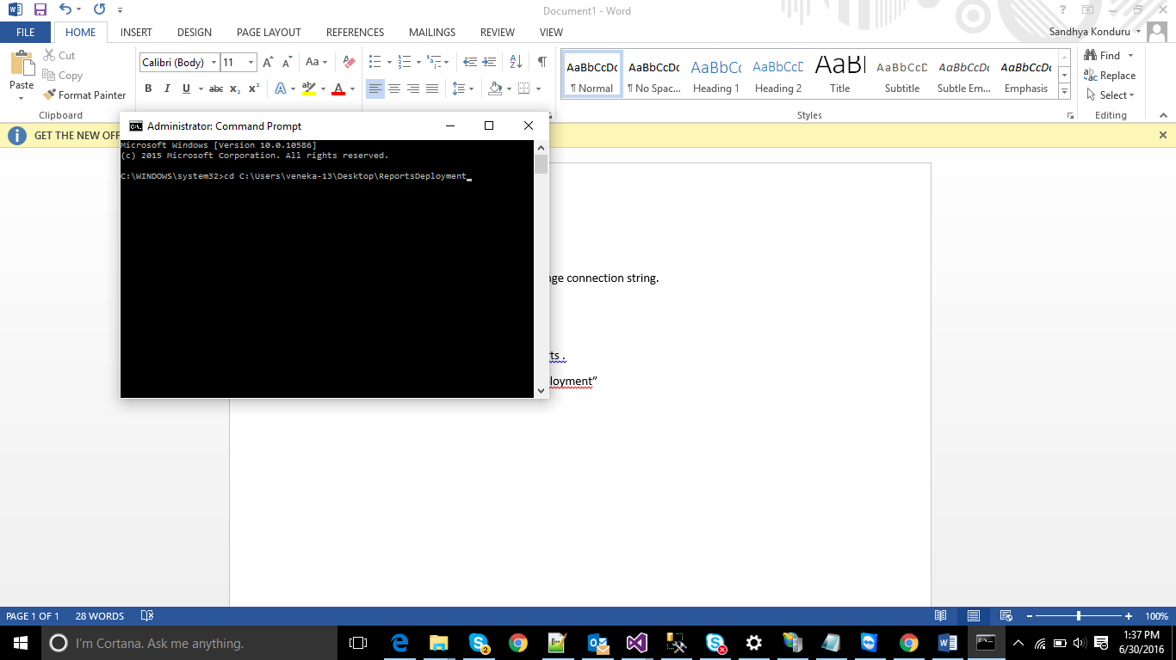

Run the deploy.bat http://servername/reportserver "Veneka.Indigo.ReportManagement"

Servername: where the reportserver located.

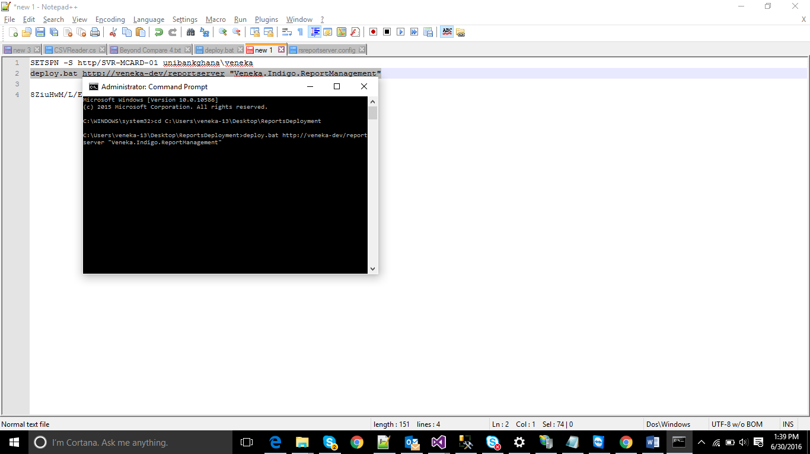

Click Enter

You will see the messaged it deployed. If it already exist it will ask for the y or N

If you want to replace press Y.